Emerging Methods for Early Detection of Forest Fires - IBM-Project-29170-1660121813

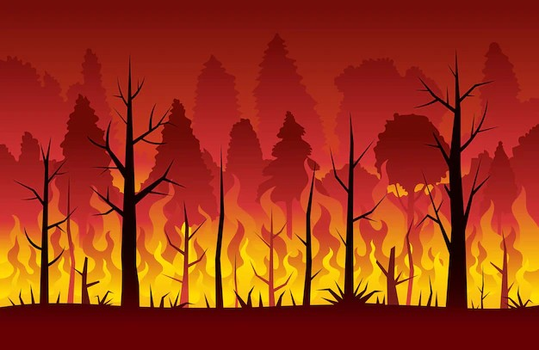

**What do they THINK and FEEL?**

Detects the fire immediately sound the alarm,sending a signal to the cloud and notifying emergency service

Detecting a fre qiuckly and accuratly

Fire detection system can limit the emission of toxic products created by combusion

# PAINS

What are their fears, frustrations, and anxieties?

K means clustering algorithm characterized by high stabilization and versatility

Applying the machine learning techniques to fre detection systems has many limitations.

# GAINS

What are their wants, needs, hopes, and dreams?

Sensor analyzes the data it collects right there on a spot

# What do they HEAR?

What are they hearing others say? What are they hearing from friends? What are they hearing from colleagues? What are they hearing second-hand?

Limited amount of energy ,the energy reqiured for the data processing

# What do they SEE?

What do they see in the marketplace? What do they see in their immediate environment? What do they see others saying and doing?

What are they watching and reading?

# What do they DO?

Three types of alarm monitoring system are used ionosation,photoelectric and combination.

Improve the fre detection in real time and accurate.

What do they do today?

What behavior have we observed? What can we imagine them doing?

**What do they SAY?**

Automated early fire detection protecting the global enviroment.

What have we heard them say? What can we magine them saying?

Detection of the fre conditions,two analytical methods are used namely,threshold ratio analysis and analsis using a machine learning algorithm

Radio acoustic sounding systems with fne space,time resolution capablities for monitoring is proposed